Centre for Rural Economy
Institute for Agri-Food Research & Innovation
School of Agriculture, Food and Rural Development
Agriculture Building
Newcastle University
Newcastle upon Tyne
NE1 7RU
UK
Email: mark.reed@newcastle.ac.uk
www.profmarkreed.com

Participant information and consent form

Thank you for agreeing to take part in an evaluation of the effects of training and resources provided by Fast Track Impact Ltd. This Participant Information Statement and Consent Form explains what will happen if you choose to take part in this evaluation, so you can make an informed choice about whether or not to take part. Participation is voluntary.

What will I be asked to do if I participate? Meetings will normally take place face-to-face, but if necessary can be conducted by telephone or Skype for up to 60 minutes.

What will happen to the information I provide? The meeting will be in two parts. The first part is not recorded and is an opportunity for you to ask questions and get support for your own impact. The second part is recorded with your consent (audio only) and transcribed. You have the option (below) to remain anonymous or allow your name to be associated with the data you provide. Data will be stored securely for 7 years before being destroyed, and will only be used by the team conducting the evaluation at Fast Track Impact and the Centre for Rural Economy, Newcastle University. You can request a copy of the data. Data will be analysed and may be used in a case study for REF2021 (for more information visit www.ref.ac.uk), and related publications and presentations about the case study. If you would like to receive a copy of the case study when it is published, please indicate this below (however, note that the case study will be made public in 2022 at impact.ref.ac.uk).

What if I want to withdraw from the evaluation? If you do consent to participate, you may withdraw at any time by contacting Prof Reed. You are free to leave the interview discussion at any time. You may also refuse to answer any questions that you do not wish to answer during the interview. If you decide to withdraw from the study, you can request that your data is destroyed.

Who is conducting the evaluation? The evaluation is being led by Mark Reed under the auspices of the Centre for Rural Economy at Newcastle University, with ethics clearance from Newcastle University, and administrative support from Fast Track Impact. A copy of the Newcastle University ethics permission for this evaluation is available on request from Prof Reed.

Please indicate your consent and sign overleaf.

Yours faithfully
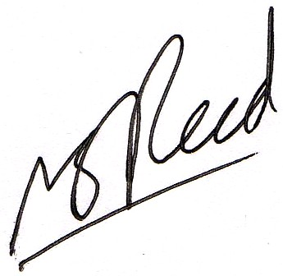
Prof Mark Reed

Please tick both, if you agree:
- I have read the Participant Information Sheet and understand the purpose of the research
- I freely agree to participate in this evaluation as described and understand that I am free to withdraw at any time during the project

Please tick one:
- I consent to being referred to by name in the REF impact case study and any other publications relating to the case study; or
- I consent to being referred to by my place of work and title in the REF impact case study and any other publications relating to the case study; or
- I consent to the information I provide being used for the purposes of the aforementioned study only if it is fully de-identified (anonymized)

Optional:
- I would like to receive a copy of the case study when it becomes publicly available

Name of Participant (please print):_________________________________________

Signature of Participant:_________________________________________

Date:_________________________________________

Declaration by Researcher:
I have given a verbal explanation of the evaluation, its study activities and risks and I believe that the participant has understood that explanation.

Researcher Signature:

Date: ________________________________________

