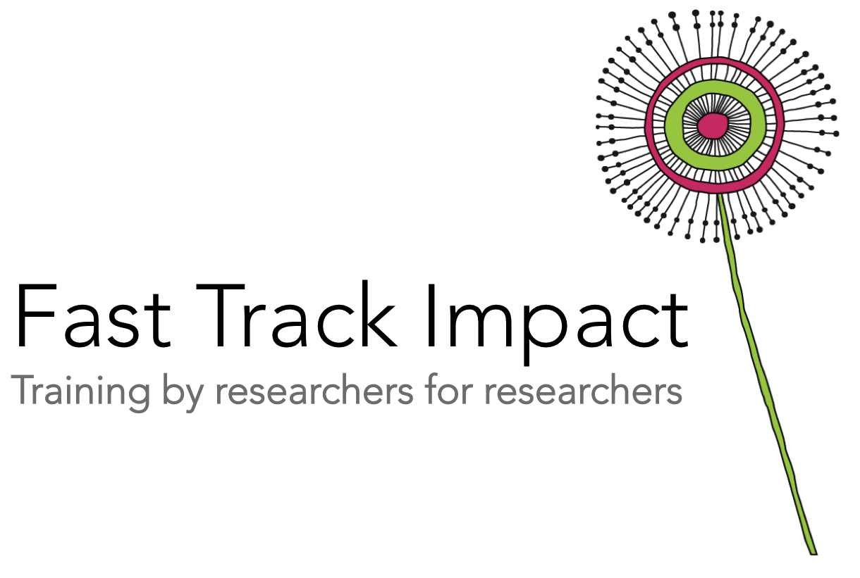
Social media strategy

If you can answer these four questions, then you’ve got yourself a social media strategy. You don’t have to write anything down – you just need to act on the answers to these questions to stop wasting time and start generating impacts on social media. Of course if you want to write stuff down, this template is for you. Use the template below and the prompts on the following pages to pin down a clear strategy.
- What offline impacts do you want to achieve via social media?
- Who are you trying to reach, what are they interested in & what platforms are they on?
- How can you make your content actionable, shareable and rewarding for those who interact with you, so you can start building relationships and move the conversation from social media to real life?
- Who can you work with to make your use of social media more efficient and effective?

The template below is a quick and easy way to organize your thinking and keep track of you progress towards impact based on your use of social media:

Impact goal | What would I expect to see happening offline that would indicate my engagement with social media is moving me closer to this impact goal? | Which stakeholders or publics on social media can help me reach this goal? | Which social media platforms are these stakeholders and publics most active on? | What aspects of my research are these stakeholders and publics most likely to be interested in? | Linked to these interests, what content, resources or opportunities would these groups find most valuable or rewarding? | What actions or activities could I promote via social media to encourage deeper engagement with my research, which might lead to conversations offline that could help achieve impact? | What are the main social media accounts that have content linked to this impact goal? What can I learn from their most popular material? Regularly update this list of accounts and insights, and promote your work to their followers by directly requesting retweets/likes or following their followers.

  - 1. What impacts do you want from your use of social media?
The number one reason people waste time on social media is that they do not have a clear goal for what they are doing. If you want your time on social media to really count, you need to know exactly what you are trying to achieve.
- Use the Fast Track Impact Planning Template to devise a broad impact plan for your research
- Identify any strands to your impact that could be achieved via social media, and write your impact goals for social media in the first column of the template. Try and make them as SMART (Specific, Measurable, Attainable, Relevant, and Timely) as possible.
- Identify indicators that will tell you if your use of social media is taking you closer to the offline goals you have identified from your Impact Plan. Social media metrics is the easy part. Put some thought into easily-measured indicators that will tell you if you are beginning to translate online influence into offline impact
- Choose easy-to-measure indicators that will show you whether or not your engagement with social media is moving you closer to your impact goals

  - 2. Who are you trying to reach?
If you know your audience, you will be able to generate content that they love, and start to build influence online:
- Use the Fast Track Impact Stakeholder and Public Analysis Template to systematically identify groups of stakeholders and publics most likely to be interested in your work, or who might benefit from or be able to use your work to help you achieve your impact goals. Write down these groups in second column of the template
- Using the same template, identify what aspects of your research these stakeholders and publics are most likely to be interested in
- Identify which social media platforms these stakeholders and publics most active on. If you are using a different platform, you will need to switch

  - 3. How can you make your content actionable, shareable and rewarding?
If you want your message to travel far and wide, it is worth thinking about how to craft messages that are shareable, rewarding and likely to lead to actions that can help you reach your impact goals:
- Linked to the interests of your stakeholders and publics, what content, resources or opportunities would these groups find particularly valuable or rewarding?
- What actions or activities could I promote via social media to encourage deeper engagement with my research, which might lead to conversations offline that could help achieve impact?

  - 4. Who can help me?
There are a number of ways you can get your message out without having to have a huge following:
- First, identify the main social media accounts that have content linked to your impact goals
- Identify what you can learn from their most popular material, so you can raise your game
- Promote your work to their followers by directly requesting retweets/likes or following their followers
- Consider taking a team approach to your social media, if there are others you work with who are naturally good at crafting messages on social media or who already have large followings. Agree to promote each other’s material where relevant. Consider asking your post-doc to manage the project social media presence if they are naturally more competent than you

